U1

1. F(x)=x^3/2🡪

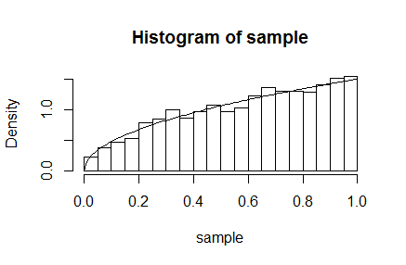

Generated data follows the true distribution

2.

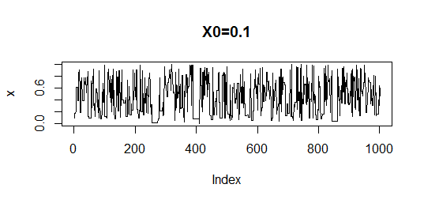

The chain seems to converge, the burn-in period is very small. Mixing is relatively OK, sometimes the chain does not move.

3.

|  |
| --- |
| > print(mean(x))  [1] 0.4360584  > print(2/3*mean(sample/(sample+0.1)))  [1] 0.5473854  > integrate(pf1,0,1)  0.5466419 with absolute error < 1.5e-05 |
|  |
| |  | | --- | | > | |

The inverse CDF gives best results, because a) samples in MCMC are not independent, b) the function that we integrate in inverse CDF is almost proportional to sqrt(x) 🡪 a low variance is expected. Beta distribution has a shape which is very far from x*sqrt(x)/(x+0.1)

U2

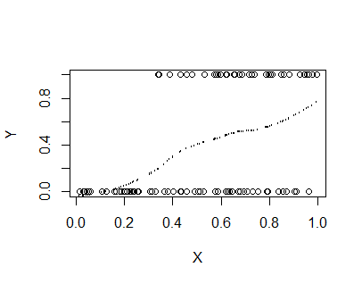

Probability model is almost linear, but there is some non-linearity which can be compensated by a quadratic term

2

$$-logP(D|w)=-∑\left(Y_{i}\log{p_{i}}\right)-∑\left(1-Y_{i})\log{(1-p_{i}}\right)$$

Results:

First point

> res

$par

[1] 0.4158831 0.3871507

$value

[1] 53.36176

$counts

function gradient

16 6

$convergence

[1] 0

Second point: same results

Third point: > optim(c(0.9,0.1),ll,method="BFGS", data=data1)

$par

[1] 0.4162747 0.3866716

$value

[1] 53.36176

$counts

function gradient

35 8

$convergence

[1] 0

Almost the same values, but more iterations. Can be a local minimum.

3

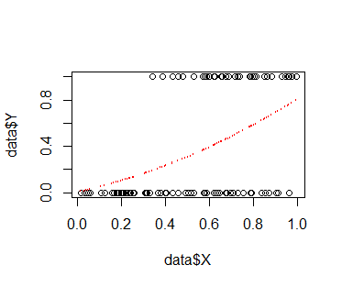

Curve looks similar, but there are no local peaks

4

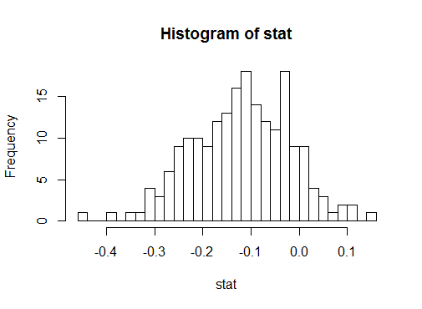

Test statistics is[1] 0.3871507

P-value is [1] 0.01

The null-hypothesis is rejected, w_2 should be there in the model.

Not-succeeded:

Z

-0.2355965

[1] 0.18

W_2 rejected.